Name: Aditya Nalini

Registration Number: 19BCE0980

Lab 1: Resume

Code:

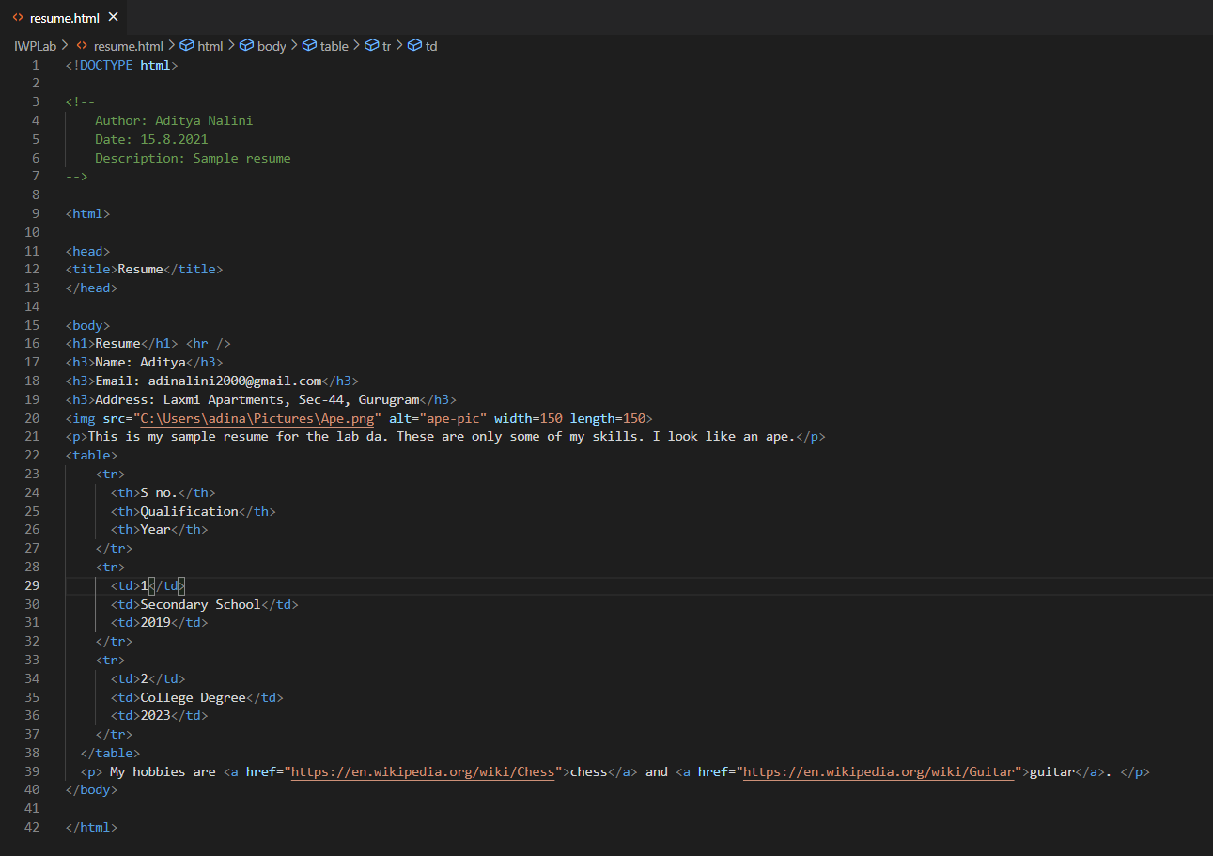

<!DOCTYPE html>

<!--

Author: Aditya Nalini

Date: 15.8.2021

Description: Sample resume

-->

<html>

<head>

<title>Resume</title>

</head>

<body>

<h1>Resume</h1> <hr />

<h3>Name: Aditya</h3>

<h3>Email: adinalini2000@gmail.com</h3>

<h3>Address: Laxmi Apartments, Sec-44, Gurugram</h3>

<img src="C:\Users\adina\Pictures\Ape.png" alt="ape-pic" width=150 length=150>

<p>This is my sample resume for the lab da. These are only some of my skills. I look like an ape.</p>

<table>

<tr>

<th>S no.</th>

<th>Qualification</th>

<th>Year</th>

</tr>

<tr>

<td>1</td>

<td>Secondary School</td>

<td>2019</td>

</tr>

<tr>

<td>2</td>

<td>College Degree</td>

<td>2023</td>

</tr>

</table>

<p> My hobbies are <a href="https://en.wikipedia.org/wiki/Chess">chess</a> and <a href="https://en.wikipedia.org/wiki/Guitar">guitar</a>. </p>

</body>

</html>

Output:

